|  |
| --- |
| Brown University |
| SharpShapes Demo (v1.1) Guide |
| User guide for the Sharp Shapes Demo (v1.1) application |

|  |
| --- |
| ez  10/4/2011 |

Contents

Introduction 3

Mode: ShapeRecognition 3

Mode: TemplateRecognitionFeedback 4

Mode: TemplateRecognitionDirect 8

Template Types 9

OrgChart 9

TableDiagram 9

PieChart 10

VennDiagram 10

BullsEye 11

PyramidDiagram 11

# Introduction

The demo application has three different modes, “ShapeRecognition”, “TemplateRecognitionFeedback” and “TemplateRecognitionDirect”. The User can toggle between them [1]. The clear button [2] removes all existing strokes and shapes from the canvas. The menu entries Save and Load [3] are mainly used for testing purposes. A user can save all drawn strokes (no shapes) and then load them again. This helps to test the different template recognition modes. The other buttons [4] are only enabled for different modes and are explained in the mode sections below.

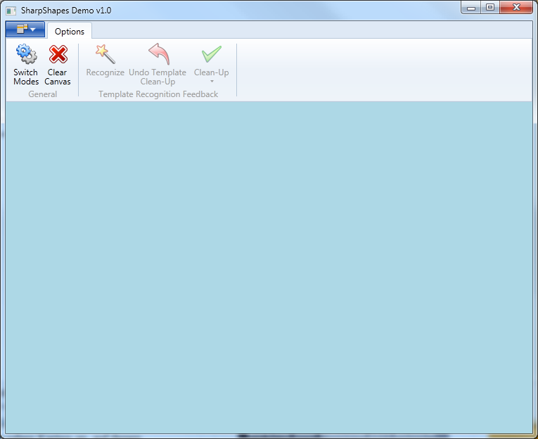

4

3

1

2

Figure : Toolbar

# Mode: ShapeRecognition

In this mode, you can draw different shapes which will automatically get cleaned up. A scribble gesture will delete all shapes under the gesture area. The following shapes are supported:

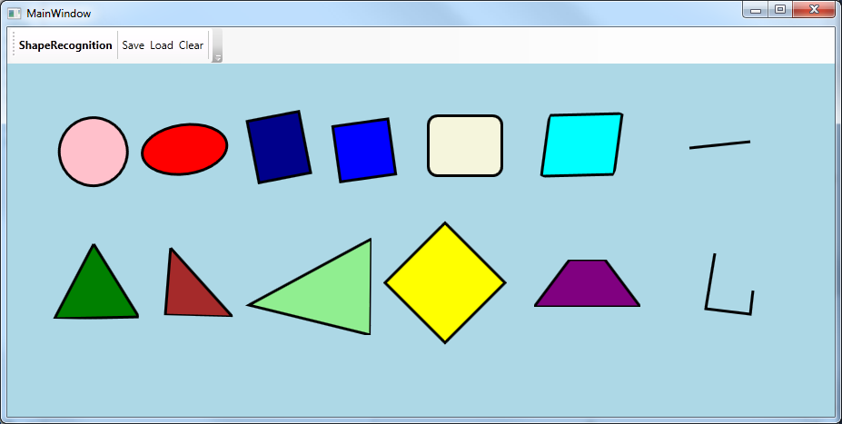

Figure : Shapes (Top: Circle, Ellipse, Rect, Square, RoundedRect, Parallelogram, Line / Bottom: IsoscelesTriangle, RightTriangle, Triangle, Diamond, Trapezoid, Polyline)

A shape can be drawn in different ways. The ordering of the single strokes or the timing between them does not matter.

Figure : Different ways to draw a rectangle

# Mode: TemplateRecognitionFeedback

In template recognition feedback mode the shapes that a user draws do not get cleaned up automatically. Clean-up can be triggered by the user whenever the system recognizes one of the following templates:

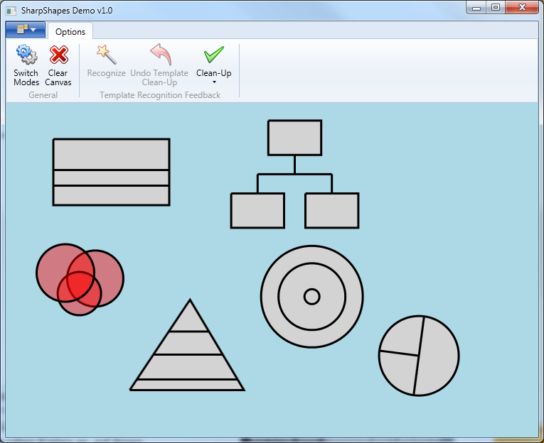

Figure : Top: TableDiagram, OrgChart / Bottom: VennDiagram, PyramidDiagram, BullsEye, PieChart

The template recognition is based on the shape recognition, so the way to draw / erase shapes and strokes is exactly the same. In the template recognition feedback mode, the system provides some feedback while the user is in the process of drawing a diagram. Strokes that are recognized as a shape will get a different color [Figure 5]. This provides some help for the user since the system requires certain building blocks of a diagram to be of a specific shape type. As soon as the system identifies a template on the canvas, all strokes that are part of it will be drawn slightly thicker [Figure 6]. The system adds buttons to the Clean-Up menu for each template that has been recognized in the scene [Figure 7]. Clicking one of those buttons triggers the clean-up process [Figure 8]. After a template has been cleaned up, the system provides the user with the option of undoing that step [Figure 8]. A cleaned up template can be edited just by adding new ink strokes to and then perform another clean-up it [Figure 9].

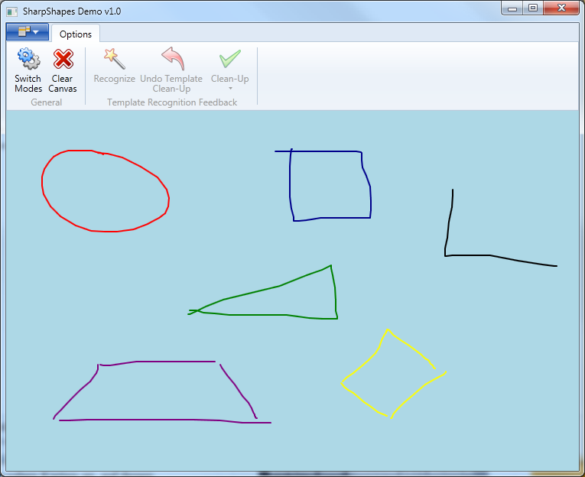

Figure : Recognized shapes will get a different color (color is the same as in shape recognition).

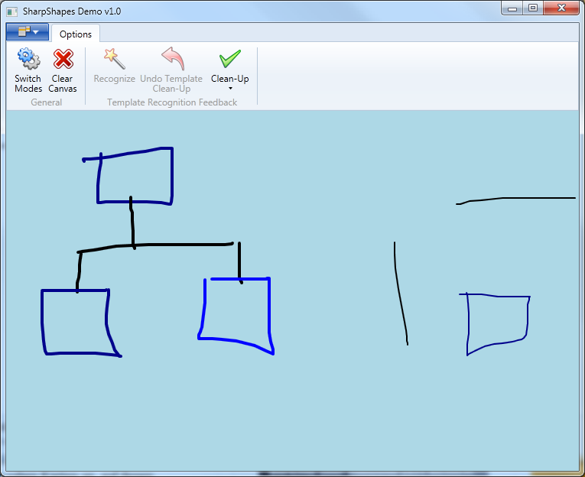

Figure : Left: Org Chart detected, so all the strokes are drawn thicker / Right: Strokes not yet part of a detected diagram.

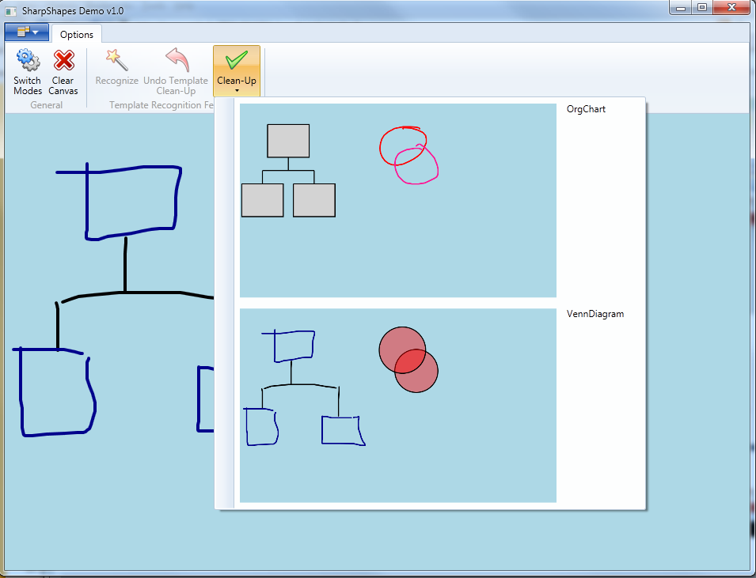

Venn Digram and Org Chart buttons added to the Clean-Up menu.

Figure : Buttons added to the top bar for the recognized templates.

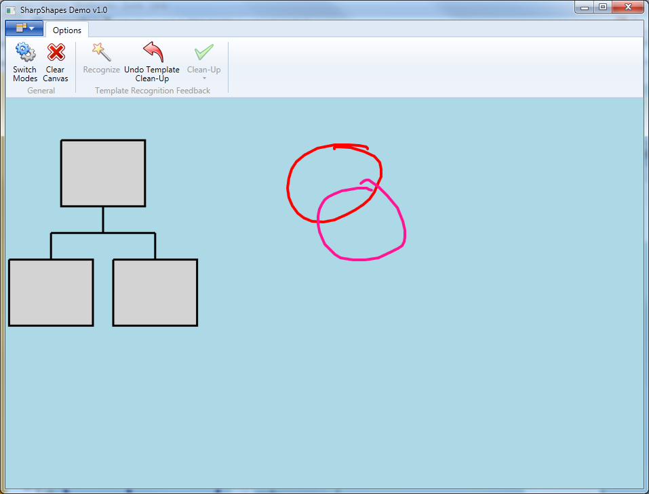

Undo Template Clean-Up button enabled.

Figure : After clicking the Org Chart button.

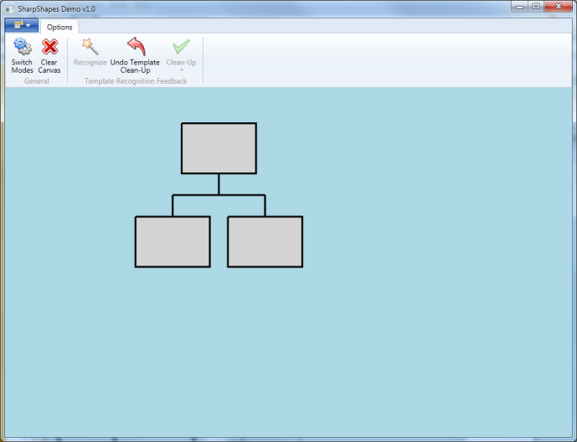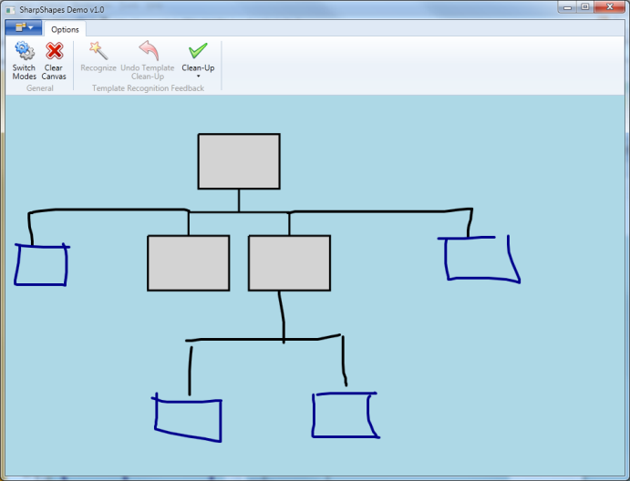

Figure : Template editing.

# 

# Mode: TemplateRecognitionDirect

The difference between this mode and the feedback mode is that template recognition is not automatically triggered. The user can decide when he wants the system to recognize a template. There is also no intermediate feedback.

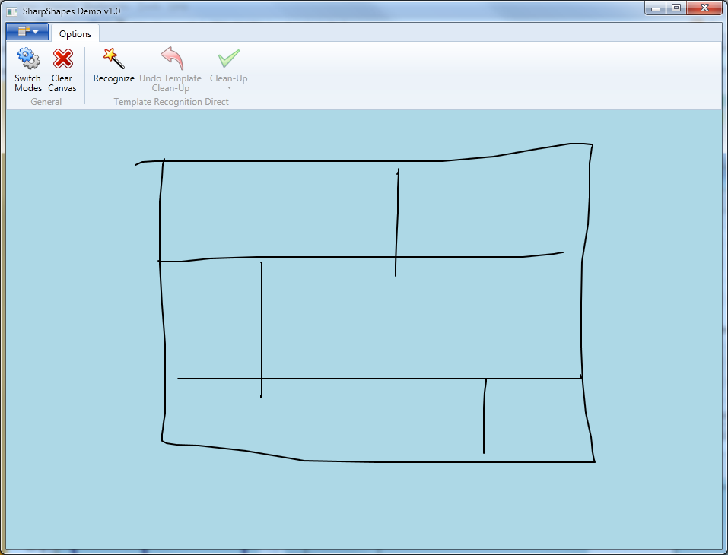

Recognize Template button enabled.

Figure : TemplateRecognitionDirect mode has a Recognize Template button.

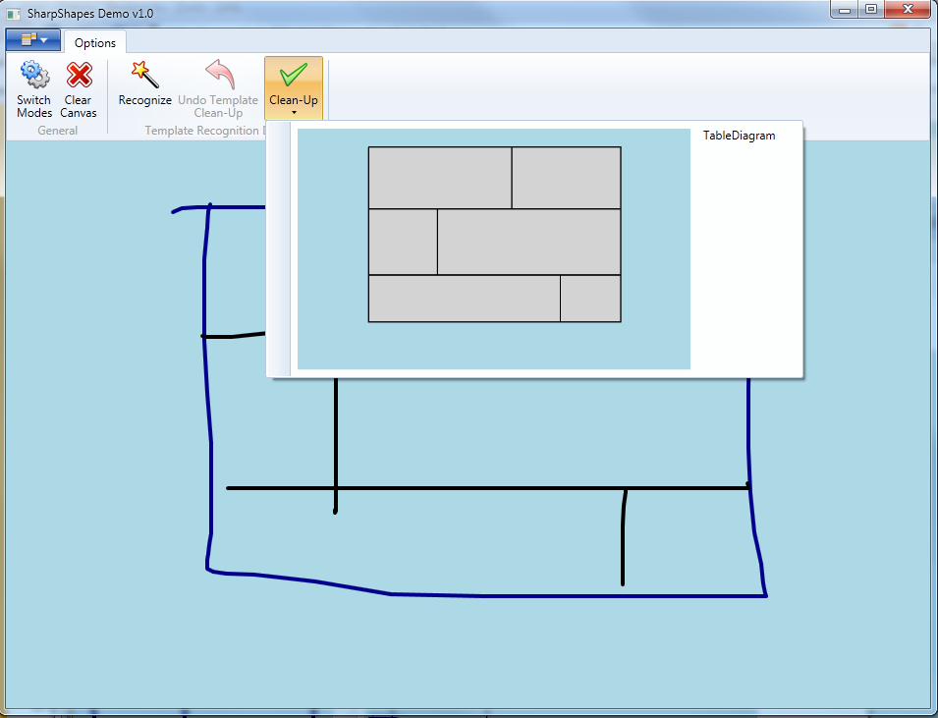

Table Diagram button added.

Figure : After the user clicks the Recognize Template button.

# Template Types

Each of the available templates has a set of rules that need to be true for it to be detected. The following section will explain those in further detail.

## OrgChart

The blocks of an OrgChart need to be recognized as any type of rectangular shape (Rect, RoundedRect, Square, Parallelogram or Trapezoid). The connections need to be a set of straight and poly-lines that are within some threshold distance of two blocks.

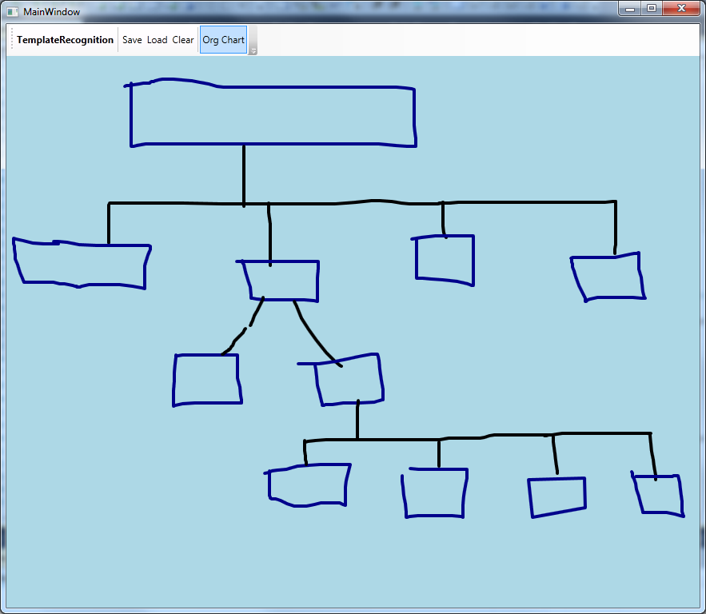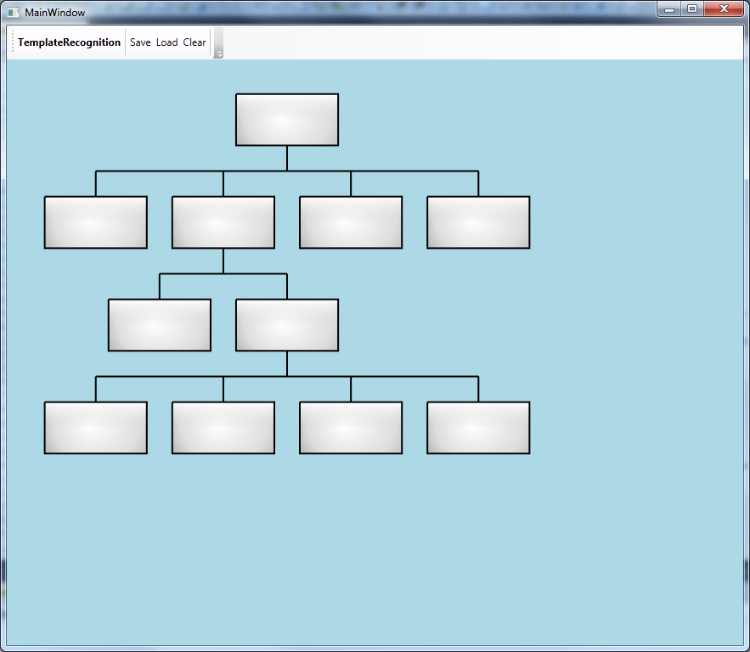

Figure : Example of an OrgChart.

## TableDiagram

The base of a TableDiagram is a rectangular shape (Rect, RoundedRect or Square). The divider lines need to be straight or polyl-lines with their end- and start-points that are contained by the base rectangle.

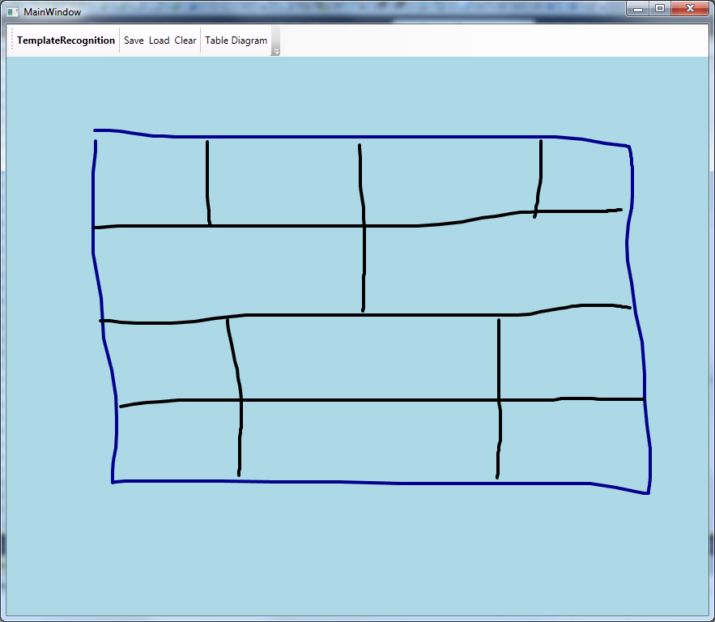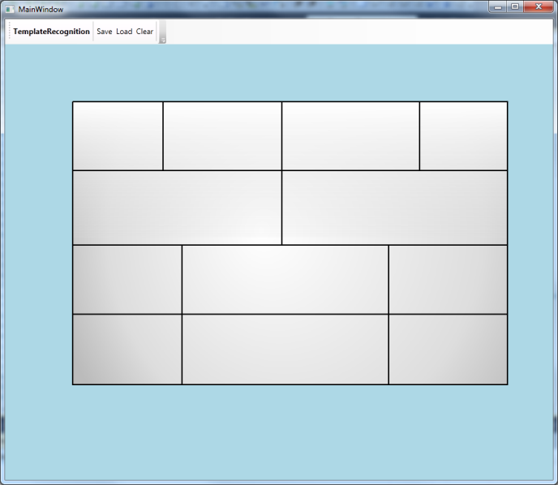

Figure : Example of a TableDiagram

## PieChart

The base of a PieChart is a circular shape (Circle or Ellipse). The divider lines need to be straight or poly-lines that are contained by the base.

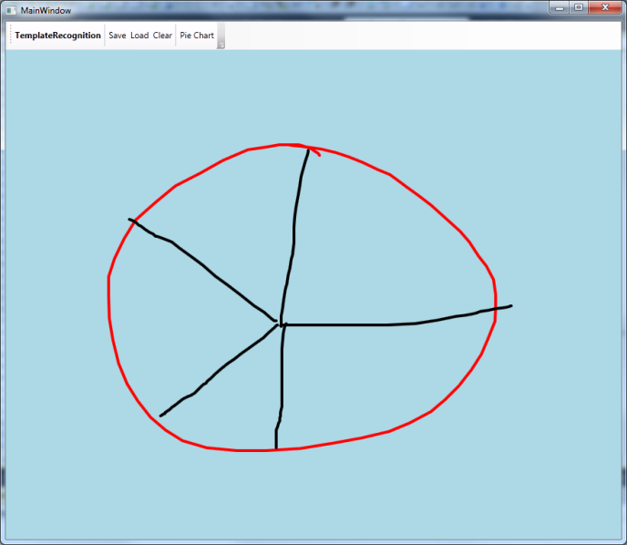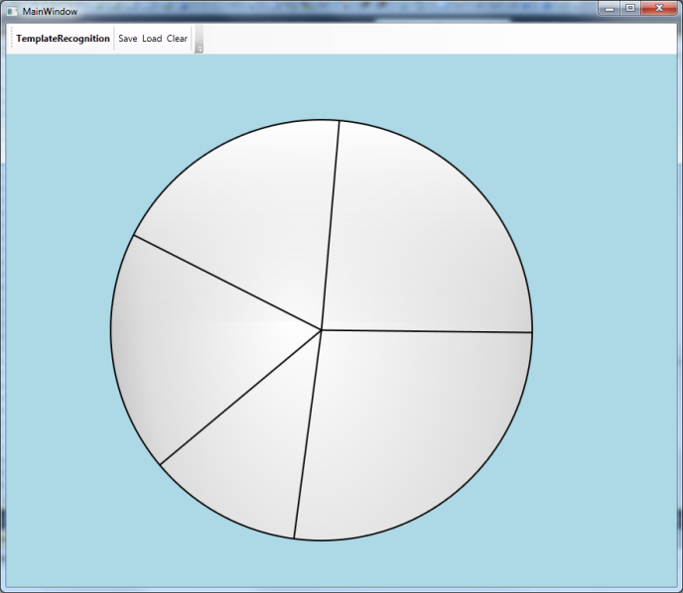

Figure : Example of a PieChart

## VennDiagram

The blocks of a VennDiagram need to be recognized as any type of circular shape (Circle or Ellipse) and need to intersect with each other.

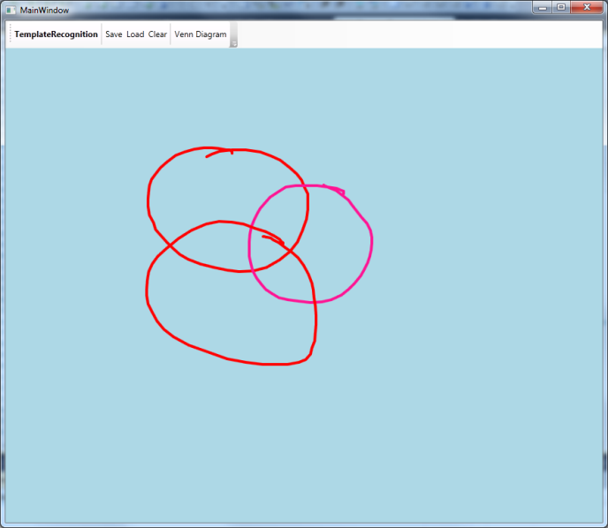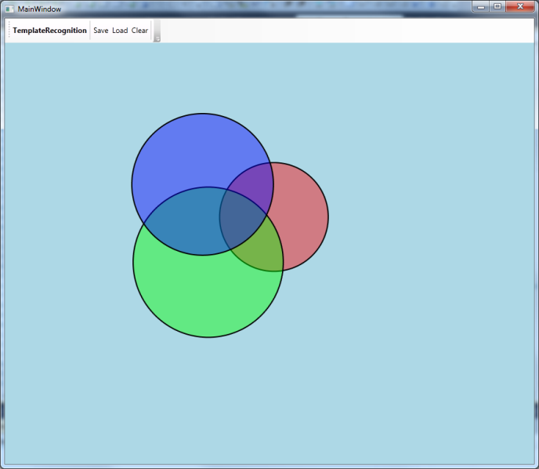

Figure : Example of a VennDiagram

## BullsEye

The blocks of a BullsEye need to be recognized as any type of circular shape (Circle or Ellipse). Each circle needs to be contained by another circle.

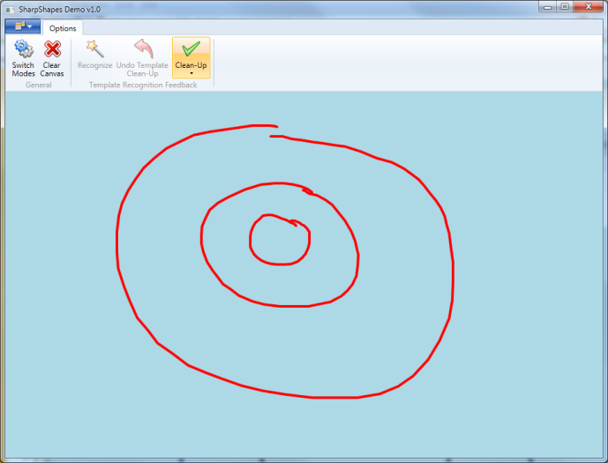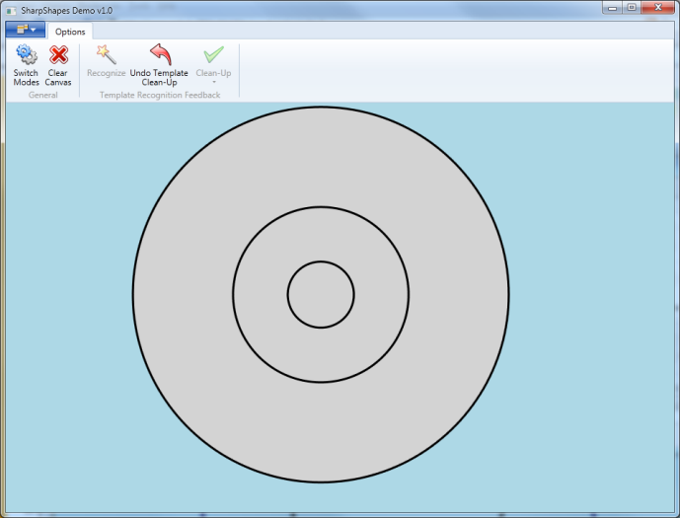

Figure : Example of a BullsEye

## PyramidDiagram

The PyramidDiagram is similar to the TableDiagram except that the base needs to be a triangular shape (Triangle, IsoscelesTriangle or RightTriangle).

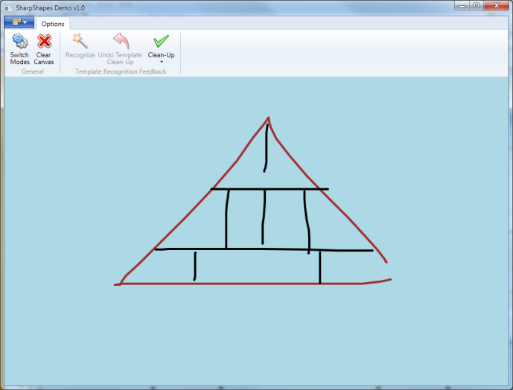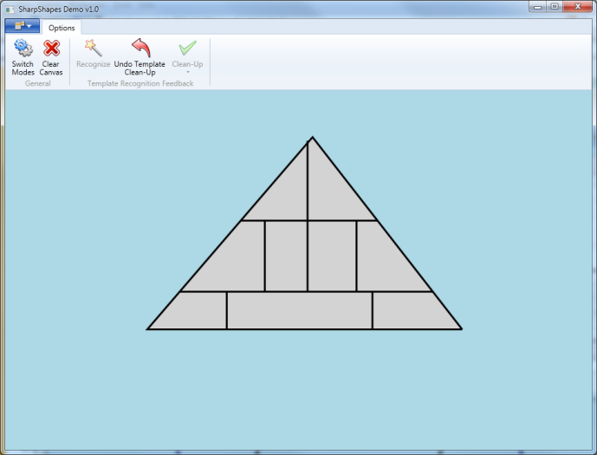

Figure : Example of a PyramidDiagram